**VPC Peering**

**What is VPC Peering?**

* VPC Peering is simply a connection between two VPCs that enables you to route traffic between them using private IP addresses. Instances in either VPC can communicate with each other as if they are within the same network. You can create a VPC peering connection between your own VPCs, or with a VPC in another AWS account within a single region.
* AWS uses the existing infrastructure of a VPC to create a VPC peering connection; it is neither a gateway not a VPN connection, and does not rely on a separate piece of physical hardware. There or no single point of failure for communication or bandwidth bottleneck.

**VPC Peering Example Configuration:**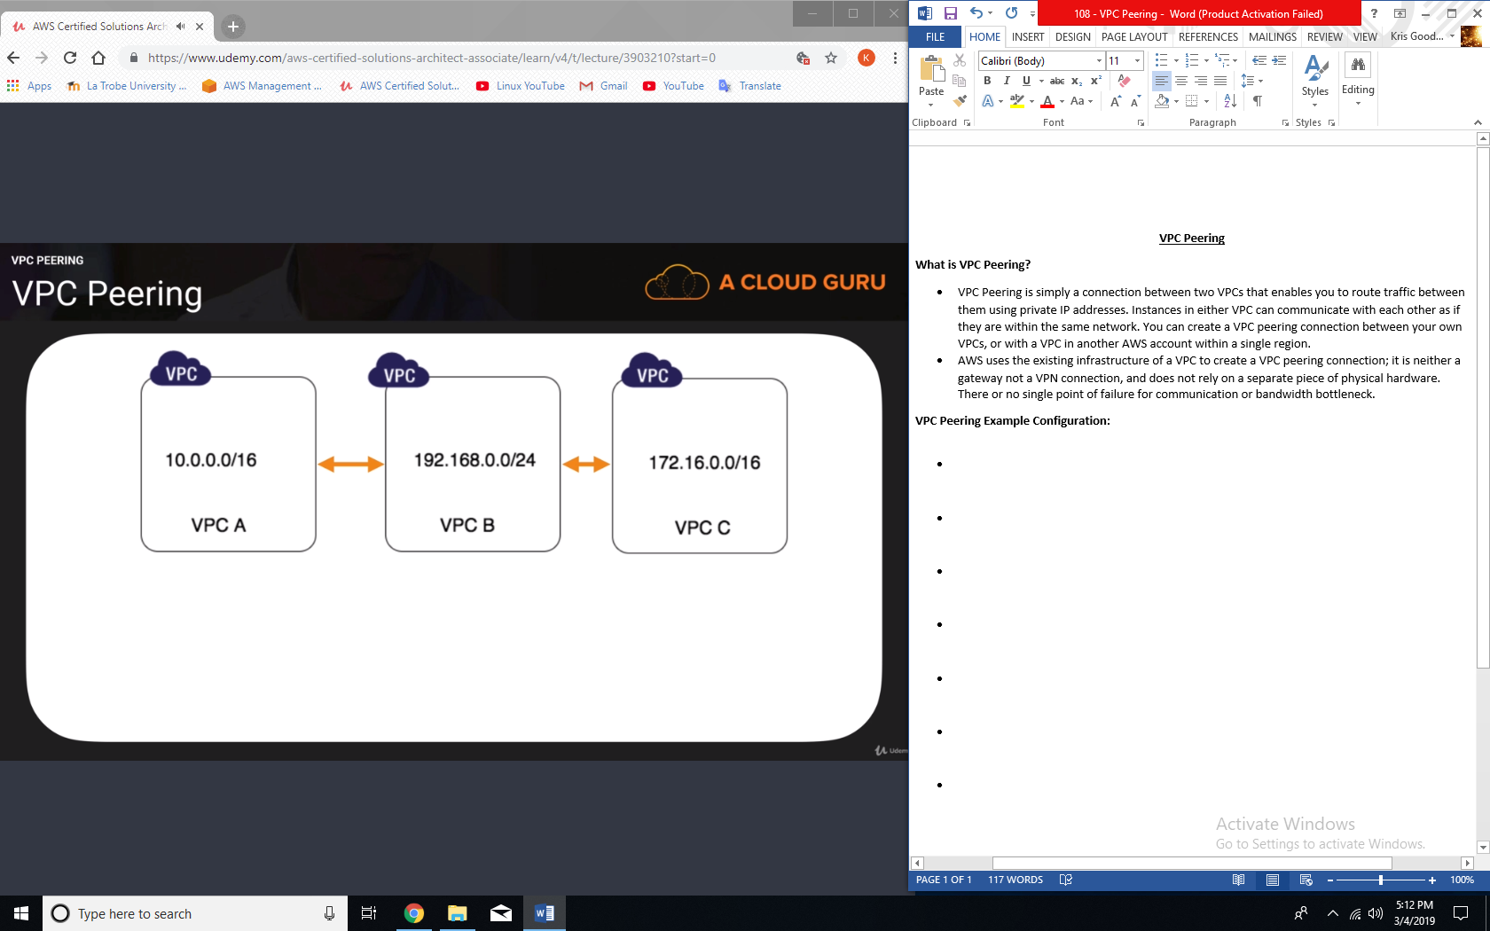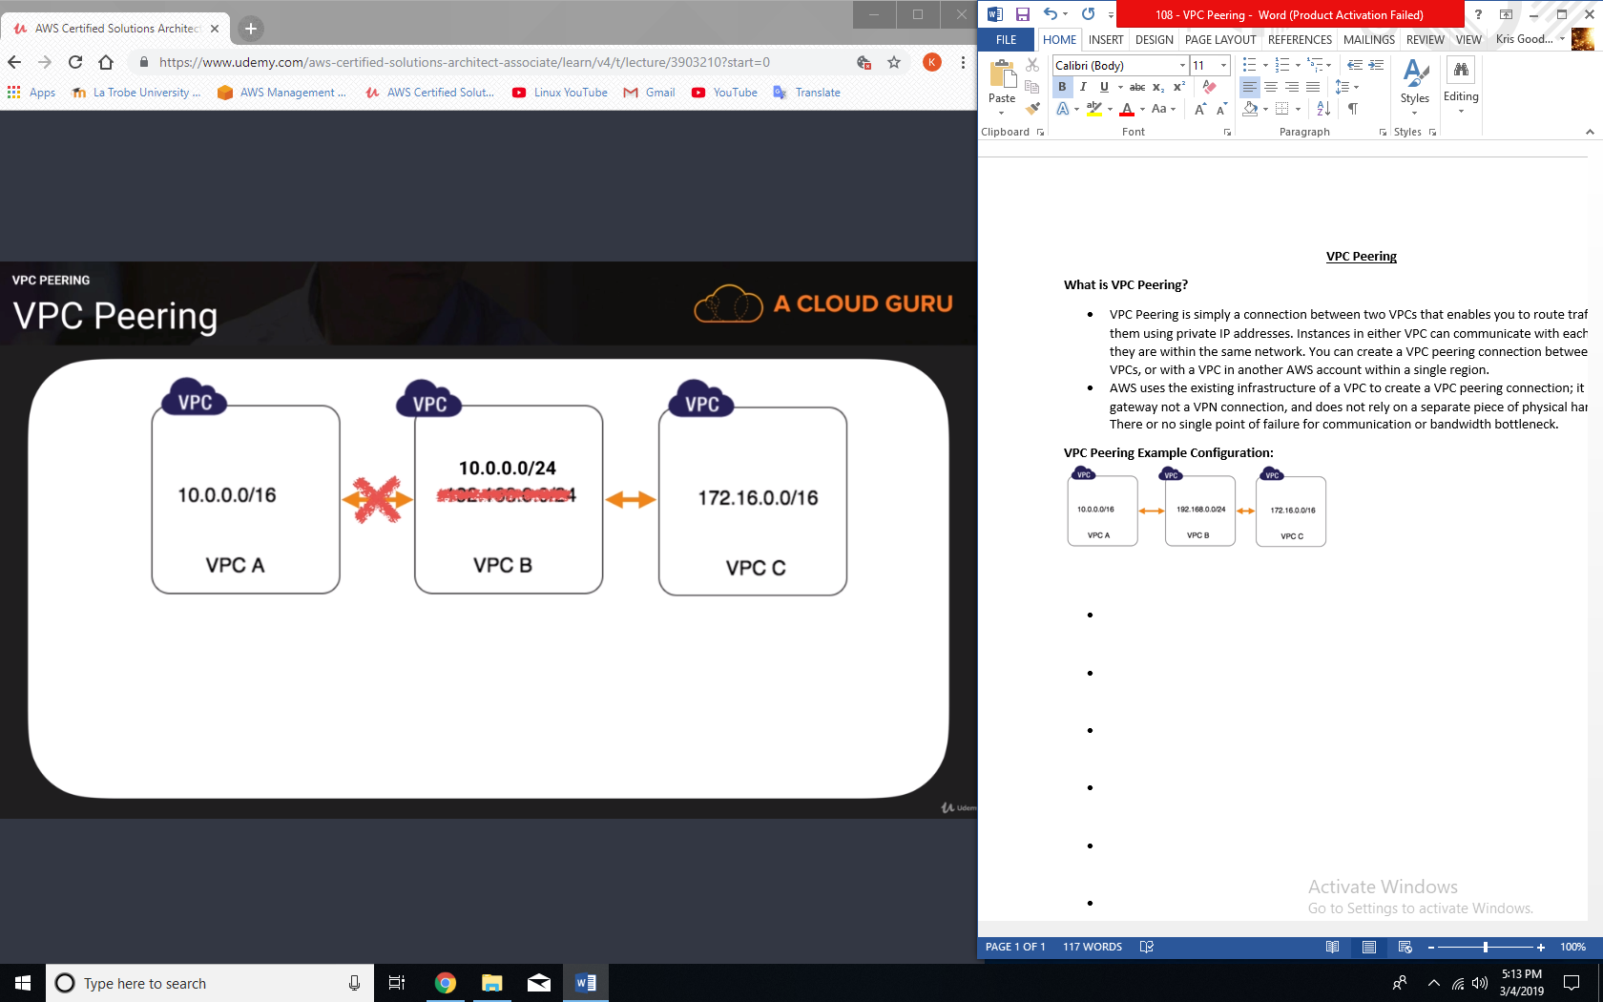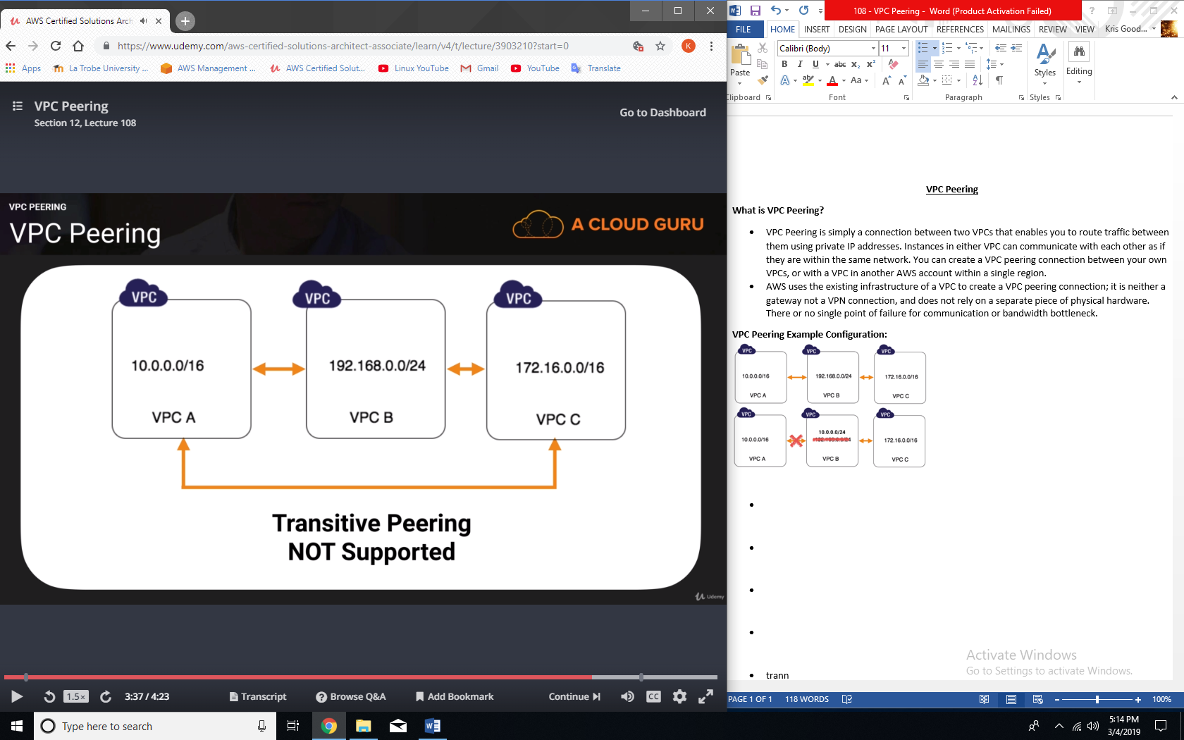

**VPC Peering limitations:**

* You cannot create a VPC peering connection between VPCs that have matching or overlapping CIDR blocks.
* You cannot create a VPC peering connection between VPCs in different regions.
* VPC peering does not support transitive peering relationships.